EOC Assignment-4

Anugrah Nambiar AMENU4AIE21016

Simple Add:

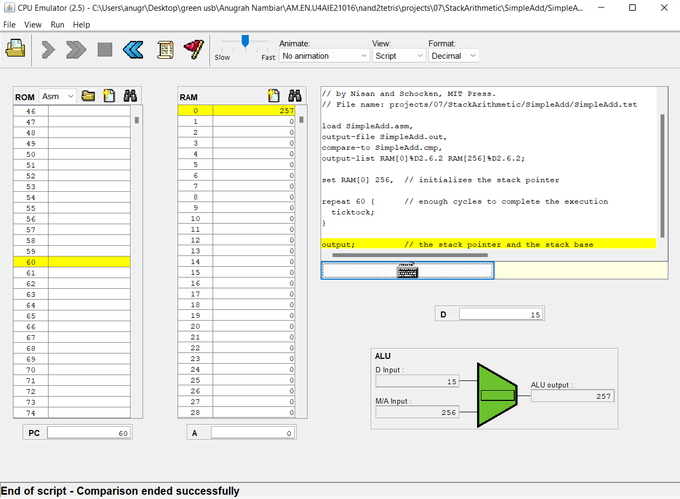

StackTest:

